<Hotel Website>

Software Requirements Specification

<1.0>

<3/11/2024>

Prepared by

<Eng. Mohammed>

<Eng. Gamal >

<Eng. Abdelrhman>

<Eng. Ziad>

<Eng. Menna>

<Eng. Malak>

<Eng. Asmaa >

<Eng. Marwan>

# Revision History

|  |  |  |  |
| --- | --- | --- | --- |
| **Date** | **Description** | **Author** | **Comments** |
| <date> | <Version 1> | <Your Name> | <First Revision> |
|  |  |  |  |
|  |  |  |  |
|  |  |  |  |

# Document Approval

The following Software Requirements Specification has been accepted and approved by the following:

|  |  |  |  |
| --- | --- | --- | --- |
| **Signature** | **Printed Name** | **Title** | **Date** |
|  | <Your Name> | <Title> |  |
|  |  |  |  |
|  |  |  |  |

**Table of Contents**

Revision History ii

Document Approval ii

1. Introduction 1

1.1 Purpose 1

1.2 Scope 1

1.3 Definitions, Acronyms, and Abbreviations 1

1.4 References 1

1.5 Overview 1

2. General Description 2

2.1 Product Perspective 2

2.2 Product Functions 2

2.3 User Characteristics 2

2.4 General Constraints 2

2.5 Assumptions and Dependencies 2

3. Specific Requirements 2

3.1 External Interface Requirements 3

3.1.1 User Interfaces 3

3.1.2 Software Interfaces 3

3.1.3 Communications Interfaces 3

3.2 Functional Requirements 3

3.2.1 User Account Management 3

3.2.2 Room Booking System 3

3.2.3 Payment System 3

3.3 Use Cases 3

3.3.1 Use Case #1 3

3.3. …. Use Case # … 3

3.4 Non-Functional Requirements 4

3.4.1 Performance 4

3.4.2 Reliability 4

3.4.3 Security 4

3.4.4 Maintainability 4

3.5 Design Constraints 4

3.6 Logical Database Requirements 4

4. Analysis Models 4

4.1 Sequence Diagrams 5

4.3 Data Flow Diagrams (DFD) 5

4.2 State-Transition Diagrams (STD) 5

5. Change Management Process 5

A. Appendices 5

A.1 Appendix 1 5

A.2 Appendix 2 5

# 1. Introduction

## 1.1 Purpose

The purpose of this SRS is to define the requirements for a hotel website that provides a user-friendly interface for users to view hotel information, create accounts, make room bookings, and handle reservations. This document is intended for the development team, stakeholders, and other project contributors.

## 1.2 Scope

The website is intended to offer:

1. An overview of the hotel, including services, payment methods, and reservation options.

2. A user account system with registration and login capabilities.

3. A booking system that allows users to reserve and cancel rooms.

## 1.3 Definitions, Acronyms, and Abbreviations

* **UX (User Experience)**  
  The overall experience a user has when interacting with the website. It covers factors like usability, navigation, accessibility, and how easy it is to accomplish tasks such as booking a room.
* **UI (User Interface)**  
  The visual elements of the website—what the user interacts with, such as buttons, forms, images, and layout. UI design focuses on making the website easy to use and aesthetically pleasing.
* Booking Engine  
  A tool or software integrated into the website that allows guests to make reservations directly from the hotel’s website. This system processes availability, rates, and payment.
* **Booking Confirmation Page**   
  The page displayed after a user completes a booking, confirming the reservation details such as dates, room type, price, and confirmation number.
* **API (Application Programming Interface)**  
  A set of protocols and tools for building software applications. It allows different systems (like a hotel’s booking engine and PMS) to communicate with each other.
* **B2C (Business to Consumer)**  
  refers to the transaction model where businesses (hotels) sell directly to consumers (guests). Most hotel websites follow a B2C model, allowing guests to book directly.
* **B2B (Business to Business)**  
  Refers to transactions between businesses. In the hotel industry, B2B might involve partnerships with travel agents, tour operators, or corporate clients for group bookings.

## 1.4 References

* **Hotel Branding Guidelines Document**:

A document that outlines the hotel’s branding standards, including colors, logos, and visual style. This will guide the design elements to ensure consistency with the hotel’s brand identity.

* **Industry-Standard UX and UI Guidelines for Responsive Web Design**:

These guidelines set the standards for user experience (UX) and user interface (UI) to ensure the website is usable and visually appealing across devices of different sizes.

## 1.5 Overview

This SRS document details the functional and non-functional requirements for the website, the specific features it will provide, and the constraints under which it will operate.

# 2. General Description

## 2.1 Product Perspective

The hotel website will serve as a standalone platform and primary online presence, designed to attract potential guests by offering an easy-to-navigate, visually appealing, and informative experience, allowing guests to view, book, and manage reservations with payment processing.

## 2.2 Product Functions

The website will offer the following key functions:

### 2.2.1 User Account Management: Account creation, login, and profile management.

### 2.2.2 Room Booking System: Functionality to browse rooms, view availability, book, and cancel reservations .

### 2.2.3 Hotel Overview: Information on hotel services, payment options, and reservation processes.

### 2.2.4 Contact and Support: Contact forms, and FAQ.

## 2.3 User Characteristics

### 2.3.1 Guests: Individuals looking to book rooms or inquire about the hotel

### 2.3.2 Hotel Staff: Authorized staff may require backend access to manage content, bookings, and customer queries.

## 

## 2.4 General Constraints

- The website must be accessible on desktop, tablet, and mobile devices.

- The design must align with the hotel's branding.

## 2.5 Assumptions and Dependencies

- It is assumed that a payment gateway (e.g., Master Card) will be integrated for online bookings.

- The website is expected to interface with a backend reservation system.

# 3. Specific Requirements

## 3.1 External Interface Requirements

### 3.1.1 User Interfaces

**User Requirements:**

Users need a clean and simple navigation bar to access sections like hotel overview, booking, account, and contact pages.

Users require an intuitive booking page featuring a calendar view for selecting dates, viewing available rooms, and their prices.

**System Requirements:**

-Implement a navigation bar with clearly labeled sections for ease of access.

-Design and develop a booking page with calendar integration to display date-based room availability and pricing dynamically.

### 3.1.2 Software Interfaces

**User Requirements:**

-Users need secure payment processing and real-time room availability while booking.

**System Requirements:**

-Integrate the system with a secure payment gateway to process Visa card payments.

-Connect the website to the backend system to fetch and update room availability and reservation data.

### 3.1.3 Communications Interfaces

**User Requirements:**

-Users should receive notifications for early check out request (under-review , approved , or denied).

**System Requirements:**

-Implement a notification system to send booking acceptance or rejection notices automatically.

### 3.1.4 Admin Interfaces

**User Requirements:**

-Admin should receive notifications for early check out requests and respond with approved or denied.

-Admin should see rooms status and can change them from available to under-Maintenance.

**System Requirements:**

-Implement a notification system to send requests and take responses booking acceptance or rejection.

-Implement a function to show all rooms with their status and be available or under-Maintenance.

## 3.2 Functional Requirements

### 3.2.1 User Account Management

**User Requirements:**

1. Users should be able to register by providing personal information.
2. Users should be able to log in to view their booking history.
3. Users should be able to check out early.

**System Requirements:**

1. Develop a registration form to capture user details securely.
2. Implement a login system with session management for authenticated access.
3. Create functionality for users to view login information and the history.

### 3.2.2 Room Booking System

**User Requirements:**

1. Users should be able to view available rooms and prices.
2. Users need the ability to book rooms for selected dates and confirm the reservation.

**System Requirements:**

1. Implement a browsing interface to display room details fetched from the database.
2. Develop a booking module that allows date selection, room availability checks, and payment processing.

### 3.2.3 Payment System

**User Requirements:**

1. Users should be able to make payments securely using their Visa card.

**System Requirements:**

1. Integrate a secure payment gateway compatible with Visa card payments

Use Case Diagram

## 3.3 Use Cases

### 3.3.1 Use Case #1.

|  |  |
| --- | --- |
| **Use case name** | Sign In |
| **Trigger** | The user wants to log into the system |
| **Preconditions** | 🡪 The user has a registered account.  🡪 The system is online and accessible. |
| **Basic Flow** | 1- The user navigates to the Sign-In page.  2- The user enters their email and password.  3- The system checks the credentials against the User Database.  4- If valid, the system grants access to the Home page. |
| **Postconditions** | The user is logged into the system and directed to the Home page. |
| **Alternate Flow** | * **Invalid Credentials**: If the credentials are incorrect, the system displays an error message and prompts the user to re-enter their login information. |

### 3.3.2 Use Case #2:

|  |  |
| --- | --- |
| **Use case name** | Sign Up |
| **Trigger** | The user wants to create a new account in the system. |
| **Preconditions** | 🡪 The user does not have an existing account.  🡪 The system is online and accessible. |
| **Basic Flow** | 1. The user navigates to the Sign-Up page. 2. The user enters their personal details, including name, email, and password. 3. The system validates the information. 4. The system saves the user's information in the User Database. 5. The system confirms the successful registration to the user.   • |
| **Postconditions** | 🡪 The user account is created and stored in the User Database.  🡪 The user can now log in to the system. |
| **Alternate Flow** | **Invalid Information**: If the user enters invalid information (e.g., missing fields), the system shows an error message and prompts the user to correct the details. |

### 3.3.3 Use Case #3:

|  |  |
| --- | --- |
| **Use case name** | View Profile |
| **Trigger** | The user wants to view or update their profile information |
| **Preconditions** | 🡪The user is logged into the system |
| **Basic Flow** | 1. The user selects the "View Profile" option from the Home page. 2. The system retrieves the user's information from the User Database. 3. The user reviews and, if desired, updates their information. 4. The system saves any updates to the User Database. |
| **Postconditions** | The user's profile information is up-to-date in the User Database. |
| **Alternate Flow** | **No Updates**: If the user does not make any updates, the system simply displays the profile information without changes. |

### 

### 3.3.4 Use Case #4:

|  |  |
| --- | --- |
| **Use case name** | **View Available Rooms** |
| **Trigger** | The user wants to see which rooms are available for booking. |
| **Preconditions** | 🡪 The user is logged into the system.  🡪 There are rooms available for booking in the Rooms Database. |
| **Basic Flow** | 1- The user selects "View Available Rooms" from the Home page.  2- The system retrieves a list of available rooms from the Rooms Database.  3- The user views the list of available rooms. |
| **Postconditions** | 🡪The user can proceed with booking if a suitable room is found. |
| **Alternate Flow** | **No Available Rooms**: If no rooms are available, the system displays a message indicating that no rooms are currently available for booking. |

### 3.3.5 Use Case #5:

|  |  |
| --- | --- |
| **Use case name** | Booking |
| **Trigger** | The user decides to book a room |
| **Preconditions** | 🡪 The user is logged into the system.  🡪 The user has selected an available room from the list. |
| **Basic Flow** | 1- The user selects a room from the available options.  2- The system marks the room as "Booked" in the Rooms Database.  3- The system prompts the user to proceed to payment. |
| **Postconditions** | 🡪The selected room is reserved for the user in the Rooms Database. |
| **Alternate Flow** | **Room Unavailable**: If the selected room becomes unavailable before booking, the system informs the user and refreshes the list of available rooms. |

### 3.3.6 Use Case #6:

|  |  |
| --- | --- |
| **Use case name** | Paying |
| **Trigger** | The user is ready to make a payment to confirm their booking |
| **Preconditions** | 🡪The user has selected a room and initiated the booking process. |
| **Basic Flow** | 1- The user is prompted to enter payment information.  2- The system processes the payment.  3- The system updates the History Database with the booking and payment details.  4- The system confirms the successful payment to the user. |
| **Postconditions** | 🡪The booking is confirmed, and payment details are stored in the History Database. |
| **Alternate Flow** | **Payment Failure**: If the payment fails, the system notifies the user and prompts them to try another payment method. |

### 3.3.8 Use Case #8:

|  |  |
| --- | --- |
| **Use case name** | Accept Cancellat |
| **Trigger** | The staff reviews and approves a user’s cancellation request. |
| **Preconditions** | 🡪 A cancellation request has been submitted by the user.  🡪 The staff is authorized to approve cancellations |
| **Basic Flow** | 1- The staff accesses the pending cancellation requests.  2- The staff approves the cancellation request.  3- The system updates the History Database to mark the booking as "Canceled."  4- The system updates the Rooms Database to make the room available again.  5- The system notifies the user of the successful cancellation. |
| **Postconditions** | 🡪 The room becomes available for future bookings.  🡪 The booking history reflects the cancellation status |
| **Alternate Flow** | **Request Denial**: If the staff denies the cancellation request, the user is notified, and the booking remains unchanged. |

### 

### 3.3.13 Use Case #10:

|  |  |
| --- | --- |
| **Use case name** | Update Room Status |
| **Trigger** | The admin selects the "Update Status" option for a specific room. |
| **Preconditions** | * The admin is logged into the system with appropriate permissions. * • The room exists in the system. |
| **Basic Flow** | 1. The admin accesses the "Manage Rooms" section from the dashboard. 2. The admin selects the room for which the status needs to be updated. 3. The system displays the current status (e.g., Available, Booked, Under Maintenance). 4. The admin selects a new status from the available options. 5. The admin confirms the update. 6. The system saves the updated status in the database. 7. • The system logs the status update for auditing purposes. |
| **Postconditions** | * The room's new status is updated in the database. * The updated status is reflected in room availability views for users and staff. |
| **Alternate Flow** | * If the admin cancels the action before confirming, the system retains the current status and returns to the "Manage Rooms" section. * If the system encounters a database error, it displays an error message and does not update the room's status. |

### 3.3.14 Use Case #11:

|  |  |
| --- | --- |
| **Use case name** | Remove a Room |
| **Trigger** | The admin selects the "Remove Room" option for a specific room. |
| **Preconditions** | * The admin is logged into the system with appropriate permissions. * The room exists in the system. |
| **Basic Flow** | 1. The admin accesses the "Manage Rooms" section from the dashboard. 2. The admin selects the room to be removed. 3. The system prompts for confirmation. 4. The admin confirms the deletion. 5. The system removes the room from the database. 6. The system logs the action for audit purposes. |
| **Postconditions** | * The room is no longer available for booking. * The room is removed from the database. |
| **Alternate Flow** | * If the admin cancels the action at the confirmation prompt, the system returns to the "Manage Rooms" section without removing the room. * If the room has active bookings, the system blocks the action and displays an error message. |

## 3.4 Non-Functional Requirements

**User Requirements:**

* Users expect the website to load quickly, function reliably, and protect their personal data.

**System Requirements:**

1. **Performance:** Ensure page load times do not exceed a few seconds on standard internet connections.
2. **Reliability:** Guarantee high availability for booking features, with minimal downtime.
3. **Security:** Use SSL encryption for secure data transmission, implement strong password policies, and comply with data protection regulations.
4. **Maintainability:** Design the content management system to allow hotel staff to update room details, pricing, and availability easily.

## 3.5 Design Constraints

The website design must adhere to hotel branding, including colors, logos, and imagery that convey the hotel’s unique ambiance.

## 3.6 Logical Database Requirements

**User Requirements:**

-Users expect their personal and booking information to be stored securely.

**System Requirements:**

**User Data:** Design a database structure to manage user and admin data.

**Room Data:** Design a database structure to manage room types, availability, and pricing.

**User Booking Data:** Design a database structure to manage bookings information.

**User History Data:** Design a database structure to manage user history.

# 4. Analysis Models

## 4.1.1 Sequence Diagrams for User

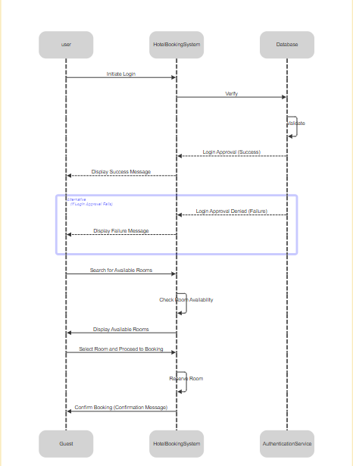

## 4.1.2 Sequence Diagrams for Admin

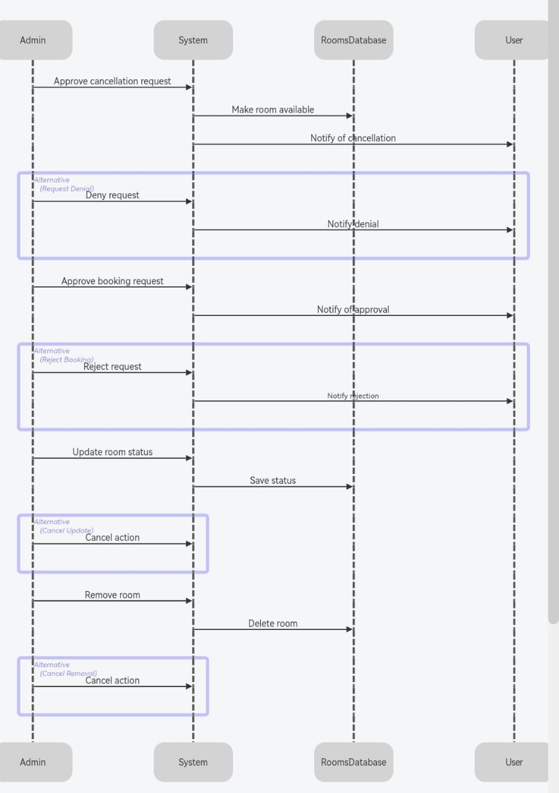

## 4.2 Data Flow Diagrams (DFD)

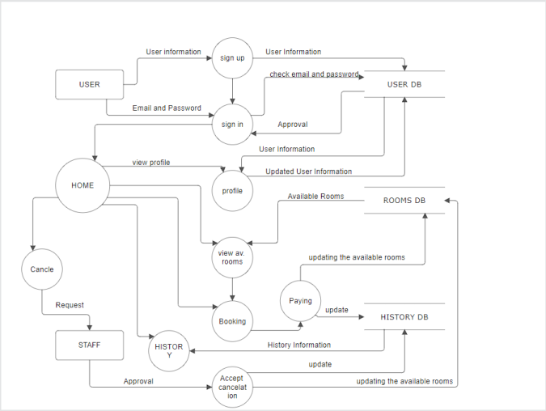

## 4.3 State-Transition Diagrams (STD)

# 

# 5. Change Management Process

All changes to this SRS must be submitted in writing and approved by project stakeholders. Minor updates can be approved by the lead software engineer, while major changes require stakeholder review.

---

A. Appendices

A.1 Sample meeting notes and design guidelines

**1. Sample Meeting Notes**

**Meeting Objective**: Discuss development goals and features for the hotel website.  
**Participants**: Development team, project manager, and hotel representatives  
**Meeting Summary**:

* **Room Booking System**: Emphasis on a user-friendly interface for viewing and booking rooms, as well as easy reservation cancellation options.
* **User Interface (UI)**: Requirement for a simple, intuitive navigation that makes main sections easily accessible (account registration, booking, support).
* **Security and Payment**: Integration of a secure payment gateway and a clear process for handling refund requests on cancellations.
* **Design Standards**: Agreement on design elements that align with the hotel's branding, such as color schemes and typography.

**2. Design Guidelines**

Since the website should match the hotel’s brand identity, design guidelines include:

* **Color Scheme**: Consistent use of colors specified in the hotel’s branding guidelines.
* **Visuals**: High-quality images reflecting the ambiance of the hotel, such as suites, dining areas, and amenities.
* **Responsive Design**: Ensure that the design works smoothly on all devices (desktop, tablet, mobile).
* **Content Layout**: Use clear fonts for readability, with straightforward, uncluttered page layouts.

A.2 Relevant marketing materials for the website

**1. Online Advertisements**

**Description**: Sample advertisements for social media platforms, such as Facebook and Instagram, to promote the website.  
**Content**:

* **Hotel Room Images**: High-quality images of rooms and amenities to convey a unique experience.
* **Special Offers**: Graphics and promotional text for deals, such as discounts on extended stays or complimentary breakfasts.

**2. Marketing Copy**

Brief promotional texts for the website, showcasing key hotel features, services, and payment policies. These materials should convey the hotel’s unique offerings, create a welcoming tone for guests, and encourage direct bookings.

---